Universidad de Guadalajara

Centro Universitario de los Valles



**Automatic recognition of violent physical actions in video surveillance systems.**

Contents

1 Introduction 3

2 Problem statement 3

2.1 Purpose 3

2.2 Scope and Limitations 3

2.2.1 Scope 4

2.2.2 Limitations 4

2.3 Audience 4

2.4 Modules 4

2.4.1 Creation of data set 5

2.4.2 Pose extraction 7

2.4.3 Classifier of violent action 8

2.4.4 Detection of violent action in real time 9

2.5 Deployment diagram 10

2.6 Technologies to use 10

2.7 Work team 11

2.8 Budget 11

2.9 Schedule 11

3 Change request specification 11

3.1 CR No. 1: Add video formats 11

3.2 CR No. 2: Weapons detection 12

3.3 CR No. 3: Saving frames 13

4 Configuration control 13

4.1 Analysis of CR and decision 16

4.2 Reasons 17

5 Status accounting 17

6 Conclusion 17

7 References 18

# 1 Introduction

Video surveillance systems are considered technological tools that help safeguard people's. Currently these systems have a great acceptance in daily life, for example, the monitoring of public areas such as airports, department stores, educational institutions, etc. With the application of current advances in digital image processing and wireless communication technology, systems can be created for the visualization and monitoring of areas of interest, capable of capturing and processing images, intelligently sending only the necessary information for the interpretation of different activities[1].

The project ARV implement a tool video surveillance with the ability to detect violent activities such as fights. The system will have the ability to highlight the 2 humans who are participating in the fight with the objective of providing aid for the visual detection of the participants in this violent action

# 2 Problem statement

## 2.1 Purpose

The interest in developing video surveillance systems to safeguard the security and protection of people grew significantly after the 11th September attack (9/11), so these systems emerge as a natural solution to detect and prevent attacks or situations that put at risk the integrity of people. Video surveillance systems have evolved over time. In 1960, the first generation of video surveillance systems emerged, which, directly focused on visual detections made by human operators, said operators had to analyze, interpret and classify the results of supervision. These types of systems did not guarantee rigorous surveillance because the attention in most individuals declines after 20 minutes of evaluating the screens. Current video surveillance systems called fourth generation (4GSS)[2], seek automation in the detection of relevant events during the monitoring of regions of interest by implementing software systems based on artificial vision algorithms. These systems are developed as support tools, to help the operator to efficiently monitor different areas of interest.

With the next project is to design and implement a tool video surveillance with the ability to detect violent activities such as fights, the system will have the ability to highlight the 2 humans who are participating in the fight with the objective of providing aid for the visual detection of the participants in this violent action

## 2.2 Scope and Limitations

The CONACYT (Consejo Nacional de Ciencia y Tecnologia) requires a computer vision system that is capable of automatically detecting violent physical actions such as kicks and punches. The ARV project will help security guards detect these violent actions quickly, the main features of the system are the following:

### 2.2.1 Scope

• The system will allow the detection of people using a camera.

• The system will perform the characterization of violent actions by extracting poses in image sequences.

• The system will allow the training of new models to detect violent actions.

• The system will allow handling different types of scenarios.

### 2.2.2 Limitations

• The system will not handle scenarios with poor lighting.

• The camera resolution must not be low in order to have visible images

• The system will be developed for a static camera

• The problem of detecting violent actions in crowds will not be addressed.

## 2.3 Audience

The software is focused on being a support tool for video surveillance systems, so it can be implemented in homes, classrooms, shopping centers, hospitals, etc.

## 2.4 Modules

The system has 4 modules in which:

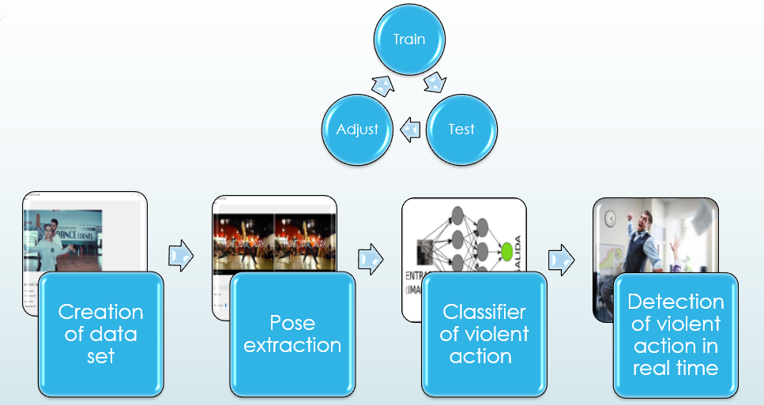

### 2.4.1 Creation of data set

This module is responsible for editing videos, this to obtain small fragments of video (around 15 frames) in order to create a fairly complete data set and then be used as a resource for training the model of fight detection.

**Requirements**

|  |  |
| --- | --- |
| **Requirement Identification:** | RF001 |
| **Name of the requirement:** | Search video |
| **Features:** | Search in any operating system directory |
| **Description of the requirement:** | This module requires the option to search for video files in the operating system folders. Only AVI, type file can be opened.  Handle exceptions when trying to open a different file. |
| **Non-functional requirement:** |  |
| **Priority of the requirement:** | high |

|  |  |
| --- | --- |
| **Requirement Identification:** | RF002 |
| **Name of the requirement:** | Play video |
| **Features:** | Play the video in a window. |
| **Description of the requirement:** | This module requires that the playback of the video on a system screen be displayed with a (Play) button. This button will be able to resume video playback. |
| **Non-functional requirement:** |  |
| **Priority of the requirement:** | high |

|  |  |
| --- | --- |
| **Requirement Identification:** | RF003 |
| **Name of the requirement:** | Pause and stop video |
| **Features:** | Buttons to stop and play a video |
| **Description of the requirement:** | In this module you have to develop two buttons one to pause the video, this button has to have the ability to save the current position of the frame that is being displayed. The stop button will restart the video to the first frame of the video. |
| **Non-functional requirement:** |  |
| **Priority of the requirement:** | high |

|  |  |
| --- | --- |
| **Requirement Identification:** | RF004 |
| **Name of the requirement:** | Time bar |
| **Features:** | Create a playback time bar. |
| **Description of the requirement:** | Create a slider that shows the total number of frames to be played and as the indicator reproduces, it must reach the right side of the slider.  The slider has the facility to position itself in any frame that the user indicates. Showing the selected frame information |
| **Non-functional requirement:** |  |
| **Priority of the requirement:** | medium |

|  |  |
| --- | --- |
| **Requirement Identification:** | RF005 |
| **Name of the requirement:** | Crop video |
| **Features:** | Trim a number of frames, to save it on the computer as video (. AVI ) |
| **Description of the requirement:** | The user must select the frame where the video should start cutting and where that cut should end. You must create a text label where the user added the amount of frames to crop.  You must have a save button and select the address where you want to save this new video |
| **Non-functional requirement:** |  |
| **Priority of the requirement:** | medium |

### 2.4.2 Pose extraction

As a second step, after obtaining the data set, this will serve to obtain the characteristics of each of the people involved in the fights, with characteristics we refer to the movements of the limbs that occur when they do a violent physical action. This information will be stored in a CSV document, which will obtain labels for violent action or non-violent action.

**Requirements**

|  |  |
| --- | --- |
| **Requirement Identification:** | RF006 |
| **Name of the requirement:** | YOLO network implementation |
| **Features:** | Implement the YOLO feature descriptor on a screen |
| **Description of the requirement:** | It is required to use the YOLO pose characteristics descriptor, displaying that information on the screen. |
| **Non-functional requirement:** |  |
| **Priority of the requirement:** | high |

|  |  |
| --- | --- |
| **Requirement Identification:** | RF007 |
| **Name of the requirement:** | Compare normal video vs feature descriptor |
| **Features:** | Show normal video and video with feature descriptor |
| **Description of the requirement:** | The user must visualize both the normal video and the video already processed marking the detection of people in the frames. |
| **Non-functional requirement:** |  |
| **Priority of the requirement:** | high |

|  |  |
| --- | --- |
| **Requirement Identification:** | RF008 |
| **Name of the requirement:** | Save information in a csv |
| **Features:** | Save all movements of people with the variables obtained from the characteristics descriptor |
| **Description of the requirement:** | Save all movements of people with the variables obtained from the characteristics descriptor in a CSV file. Label when a violent action is saved or when it is a non-violent action. |
| **Non-functional requirement:** |  |
| **Priority of the requirement:** | medium |

### 2.4.3 Classifier of violent action

As a third module of the system there is the classifier of violent physical action, this module is responsible for working with the information collected from the CSV, with this information we will adjust the classifier to obtain a reliable one (80% accuracy in detections of violent physical action).

**Requirements**

|  |  |
| --- | --- |
| **Requirement Identification:** | RF009 |
| **Name of the requirement:** | Train Neural Network |
| **Features:** | Train neural network to identify violent physical actions |
| **Description of the requirement:** | Take all the CSV files obtained from the pose extraction module and train a neural network to identify violent physical actions.  Hand punches and kicks will be identified |
| **Non-functional requirement:** |  |
| **Priority of the requirement:** | high |

|  |  |
| --- | --- |
| **Requirement Identification:** | RF010 |
| **Name of the requirement:** | Adjust neural network to identify violent physical actions |
| **Features:** | Add more networks or remove networks until you get an acceptable percentage of fight recognition |
| **Description of the requirement:** | Save all movements of people with the variables obtained from the characteristics descriptor in a CSV file. Label when a violent action is saved or when it is a non-violent action. |
| **Non-functional requirement:** |  |
| **Priority of the requirement:** | high |

|  |  |
| --- | --- |
| **Requirement Identification:** | RF011 |
| **Name of the requirement:** | Test neural network |
| **Features:** | Test neural network to identify violent physical actions |
| **Description of the requirement:** | Prove that the neural network performs well by identifying violent and non-violent actions |
| **Non-functional requirement:** |  |
| **Priority of the requirement:** | high |

### 2.4.4 Detection of violent action in real time

Module in charge of detecting violent actions in real time, with the images captured by the video surveillance camera will show an alarm when a violent physical activity is occurring in the region of interest. In this module there will be a historical panel where it will show all the events that have occurred, this to have greater control over all the violent physical actions captured by the system.

Requirements

|  |  |
| --- | --- |
| **Requirement Identification:** | RF012 |
| **Name of the requirement:** | Online detector |
| **Features:** | With the information obtained from a camera, physical violent actions are detected |
| **Description of the requirement:** | With the information obtained from a video camera, the software will identify if it is a violent action, since the information will be continuously sent to the neural network to detect these actions |
| **Non-functional requirement:** |  |
| **Priority of the requirement:** | high |

## 2.5 Deployment diagram

The deployment diagram shows the physical components of the application. In the illustration we can see that the operation is based on a desktop application infrastructure.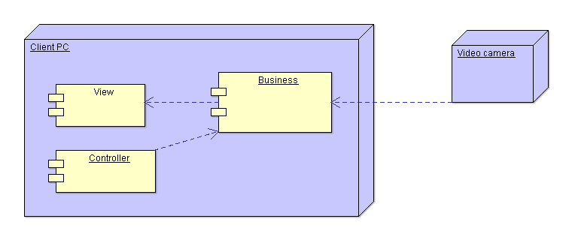

## 2.6 Technologies to use

For this system the following technologies will be used:

* Python
* Open CV
* scikit learn
* PyQT

## 2.7 Work team

• 3 Programmers  
• 2 Testers  
• 1 Technical Analyst (vision specialist)  
• 1 Project leader (vision specialist)

## 2.8 Budget

6 month project budget:

* $ 744.23 monthly programmer
* $ 694.61 monthly tester
* $ 1240.38 monthly analyst
* $ 1736.53 monthly project leader

In the development of the application you have a budget of $ 39,592.77 plus 30% profit of the software $ 11877.83.

You have a total of the project investment of: $51470.60

## 2.9 Schedule

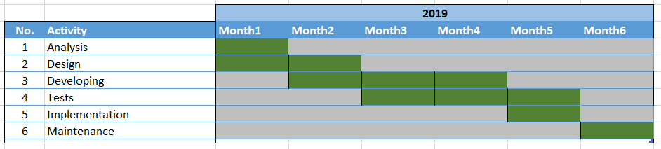

# 3 Change request specification

## 3.1 CR No. 1: Add video formats

Users need to create videos with a different extension, so when uploading videos with the 3GP, FLV and WMV extension, the ARV system sends the message that "they cannot be read". For this reason the following requirement is made.

|  |  |  |  |
| --- | --- | --- | --- |
| Add video formats | | | |
| CR No. 1 | Priority: Medium | | Date: 24/10/2019 |
| Description | | Add to the system the ability to play videos in 3GP, FLV and WMV format | |
| Liability person | | Alberto Nolasco | |
| Required time | | 15 days | |
| Required human resource | | Programmer, designer and tester | |
| Required budge | | $2,000 | |
| Impact | | RF001 and RF002 | |
| Risk | | Delays in project delivery | |
| Opportunities | | Being able to analyze different videos, which were taken in other video formats | |

## 3.2 CR No. 2: Weapons detection

Users require that weapons such as knives and guns are also detected, for this reason the following requirement is made.

|  |  |  |  |
| --- | --- | --- | --- |
| Weapons detection | | | |
| CR No. 2 | Priority: Medium | | Date: 24/10/2019 |
| Description | | Add the ability to detect white weapons and firearms to the system | |
| Liability person | | Alberto Nolasco | |
| Required time | | 3 Months | |
| Required human resource | | Project manager, designer, programmer and tester. | |
| Required budge | | $10,000 | |
| Impact | | RF006, RF007, RF008, RF012 | |
| Risk | | Delays in project delivery and adding complexity to the system | |
| Opportunities | | Create a surveillance system with superior capabilities and achieve better protection | |

## 3.3 CR No. 3: Saving frames

The users are worried about the size of the videos that are saved in AVI, this video quality is very good but when saving it to the computers the storage units will fill very fast, for this reason the following requirement is made.

|  |  |  |  |
| --- | --- | --- | --- |
| Saving frames | | | |
| CR No. 3 | Priority: Critical | | Date: 24/10/2019 |
| Description | | Prefer the system to save the frames in FLV format to comply with the standards established by the IT department. | |
| Liability person | | Alberto Nolasco | |
| Required time | | 1 Month | |
| Required human resource | | Designer, programmer and tester | |
| Required budge | | $2,000 | |
| Impact modules | | RF005 | |
| Risk | | Decreased video quality | |
| Opportunities | | Saving on storage space | |

# 4 Configuration control

In the project ARV, software and hardware components can be updated and released to the general public very frequently. It is anticipated that these upgrades will be handled through the configuration control process, or configuration control board (CCB), and will be initiated by members of the project team. The introduction of new modules and functionality through ARV customization will be controlled through the change control process or CCB as well. These changes can be initiated by project team members or ARV customers[3].

The CCB will meet as necessary to review hardware, or ARV customer change requests.

The CCB will:

* Approve specific procedures for encouraging ARV customers to identify improvements and submit change requests
* Agree on criteria for prioritizing, evaluating, and approving or disapproving change requests
* Approve a prioritized list of changes to be made on the ARV current production version
* Set schedules for issuing each new version and ensure that each new version is adequately tested and documented before issuance.

**Criteria of approve or disapprove**

Below are the criteria that CCB must take to approve or disapprove the changes:

Approve

* Have skilled human resources, and his/her/their work can be relocated on other developers.
* Have adequate infrastructure: computers, devices, servers etc.
* When the change request implies to modify the project no more than 30%
* The change request does not affect the project delivery times by 20%.
* Do not exceed the available financial resource or the change request can be absorbed by the organization.
* Do not affect multiple modules released if the change is critical.

Disapprove

* Developers with a lot of workload.
* You don't have the technology to apply the change.
* Delivery times are compromised.
* The financial resource is committed.
* The change affects critically various released modules.
* If the change request is not realistic with regards the scope, required effort.
* The performance the whole project is compromise due the change request.
* The change request implies illegitimated purposes

**Requesting Changes**

Any ARV project team member or any ARV customer may request a change or correction to the system. A ARV Change Request form must be submitted the ARV Project Manager to initiate the process or a request may be submitted to the ARV support team through ARV logged as an incident. This form, or the incident in ARV, will be used to report problems, identify new or changed requirements, and log suggestions for improvement. A ARV project team member is expected to complete the ARV Change Request form and present it to the Project Manager.

ARV customer may contact a member of the project team and take one of two steps to initiate the process.

Evaluating & Approving/Disapproving Changes

Upon receipt of an ARV Change Request form, the Project Manager will review the form for completeness, clarity, and applicability. If the form is incomplete in any way, the Project Manager will contact the submitter for clarifications. Assuming that the form is complete, the Project Manager will make an impact assessment of the change. The following is a list of impact definitions[3].

* Emergency
  + If the change is not made as soon as possible, ARV operation may be severely hampered or terminated. An emergency change request should be resolved within 24 hours.
* Critical
  + The impact of not making the change would significantly impact ARV, but would not suspend it’s operation. A critical change request should be resolved in 5 working days or less.
* Routine
  + A normal change request that can be planned, included in a current schedule or plan, and ranked among other normal actions.

For Emergency or Critical impact change requests, the Project Manager will assign the appropriate staff to the task and will inform the remainder of the project team of the situation immediately. For Routine or Deferred impact change requests, the Project Manager will present them at the next CCB meeting for discussion. The CCB may decide to approve or disapprove of the change request during the meeting, or, a project team member or members may be assigned the responsibility of researching the proposed change and reporting on system impacts. Impacts should be addressed in terms of those on the project schedule, project costs, and impact on the customers.

**Implementing Changes**

After an ARV Change Request form is approved, the Project Manager will assign the appropriate technical personnel to the task. All changes to ARV will be made in the test bed environment QA. When a change has been fully tested, a schedule will be developed to implement the change in the production environment. In most cases, the change to the production environment will be completed outside of normal working hours in order to minimize the impact to the customers. The ARV Change Request form will be updated to reflect the completed status of the request[4].

## 4.1 Analysis of CR and decision

|  |  |  |  |  |
| --- | --- | --- | --- | --- |
|  | CR1 | CR2 | CR3 |  |
| Description | Add to the system the ability to play videos in 3GP, FLV and WMV format | Add the ability to detect white weapons and firearms to the system | Prefer the system to save the frames in FLV format to comply with the standards established by the IT department. |  |
| Time | 15 days | 3 months | 1 months |  |
| Budget | $2000 | $10000 | $2000 |  |
| Human Resources | Develop, designer and tester | Develop, designer, tester and project leader | Develop, tester and designer |  |
| Priority | Critical | Low | Critical |  |
| Risks | Delays in project delivery | Delays in project delivery and adding complexity to the system | Decreased video quality |  |
| Opportunities | Being able to analyze different videos, which were taken in other video formats | Create a surveillance system with superior capabilities and achieve better protection | Saving on storage space |  |
| CB | **Approve** | **Disapprove** | **Disapprove** |  |

## 4.2 Reasons

**Change request number 1**

CB:

* Luis: This change is critical as it affects the system completely. And the cost benefit is adequate. I approve of this change
* Omar: The ARV can be used for different types of videos, this makes the system more complete. and resources are not at risk

Conclusion:

**The CB approve this change request.**

**Change request number 2**

CB:

* Luis: The change request is more complex and seriously affects the budget. This change would be a new version of the system.
* Omar: This change is very difficult, it would be like doing the project again. Time Conclusion:

**The CB disapprove this change request.**

**Change request number 3**

CB:

* Luis: The change request affects the budget and the time.
* Omar: affects the time of the project. With this change the project is in risk.

Conclusion:

**The CB disapprove this change request.**

# 5 Status accounting

Each configuration item, ARV will be tracked in detail. ARV customization will be tracked, at a minimum, by version number, release date, and capability. The tracking will be done by the Project and Configuration Managers.

* ARV software Baseline version 2.5
* Software Configuration Management Plan of ARV software version 2.0
* Change request ARV software version 1.5

# 6 Conclusion

Using SCM in projects focused on software development can guarantee an excellent order in the number of corrections and changes to the project. It also optimizes time and budget. For this reason it is good practice to implement these guidelines. The use of a CB is a good way to prioritize changes and implement corrections without putting the project's time and money at risk.

From the point of view of the audit it is an excellent tool to have control and see in what aspects the money and time was allocated. All this helps us to have as an example a successful reference project[5].

# 7 References

[1] A. Ben Mabrouk and E. Zagrouba, “Abnormal behavior recognition for intelligent video surveillance systems: A review,” *Expert Syst. Appl.*, vol. 91, pp. 480–491, 2018.

[2] A. Petrosino, *Handbook on Soft Computing for Video Surveillance*. 2012.

[3] E. H. Bersoff, “Elements of Software Configuration Management,” *IEEE Trans. Softw. Eng.*, vol. SE-10, no. 1, pp. 79–87, 1984.

[4] “Project 3,” pp. 1–7.

[5] S. Engineering, S. Committee, and I. Computer, *IEEE Standard for Configuration Management in Systems and Software Engineering IEEE Computer Society*, vol. 2012, no. March. 2012.